

1. BACKGROUND PROCESS

**Softwares:**

1. Nssm (<https://nssm.cc/download>).
2. Nodejs (<https://nodejs.org/en/>)
3. scheduleNoder.zip ( provided )

Install Nodejs latest on system, Unzip scheduleNoder.zip , Now open command prompt and navigate to scheduleNoder folder . Add node to system Environment path

Run npm install command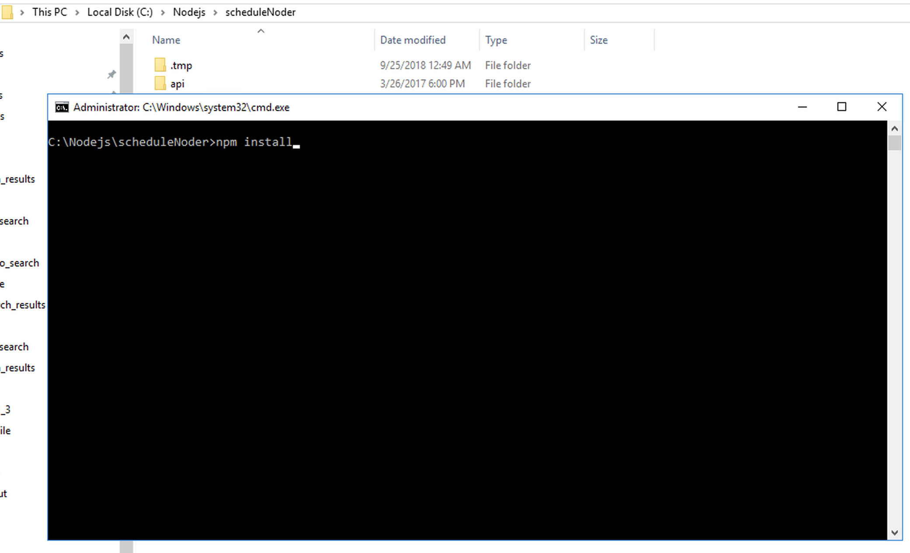

After installation completed open settings.js page inside scheduleNoder folder and set all path.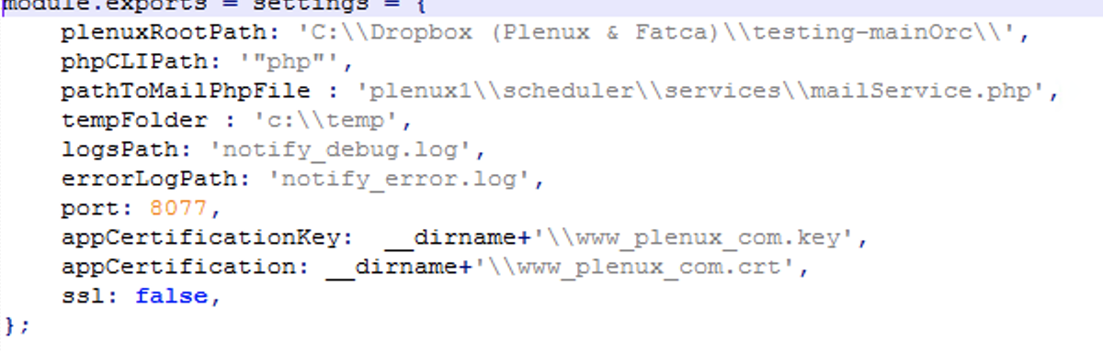

**Steps for Install Background process:**

open cmd with administrator and navigate to nssm folder

nssm install serviceNameExamp3 C:\Windows\System32\cmd.exe /c node path to app.js

eg: path to app.js => c:\Nodejs\scheduleNoder\app.js

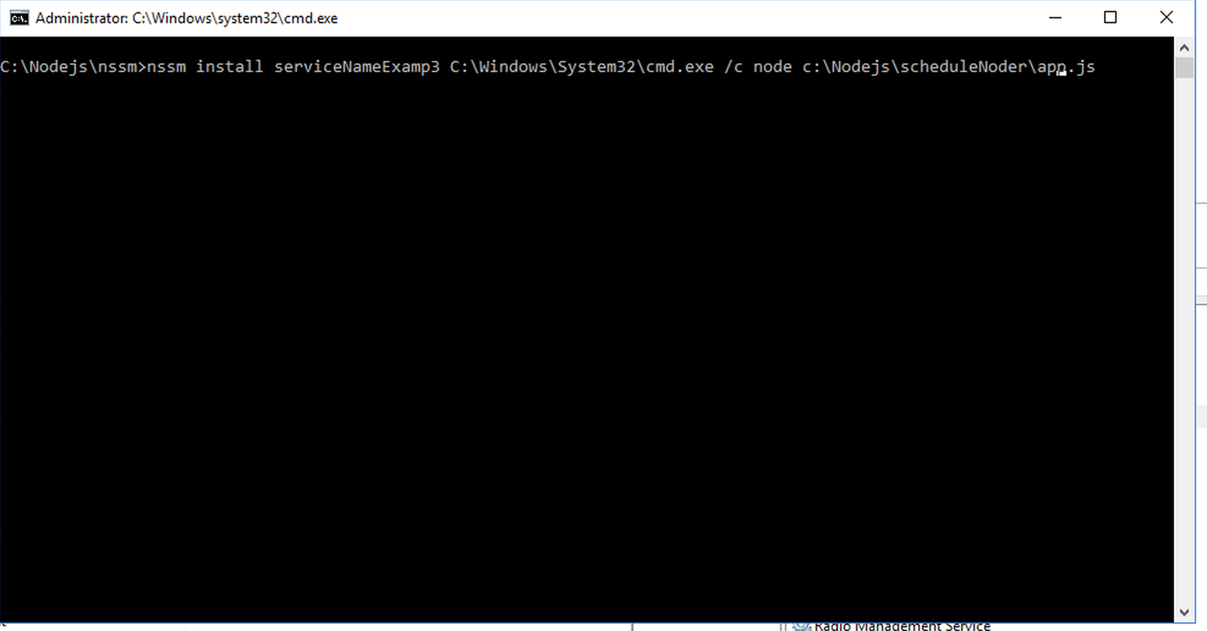

**2 . NOTIFICATION**

**Softwares:**

1. Nssm (<https://nssm.cc/download>).
2. Nodejs (<https://nodejs.org/en/>)
3. plenuxNotifier_latest.zip ( provided )

Install Nodejs latest on system, add node to system Environment path.

Unzip plenuxNotifier_latest.zip , Now open command prompt and navigate to plenuxNotifier_latest folder .

Run npm install command.

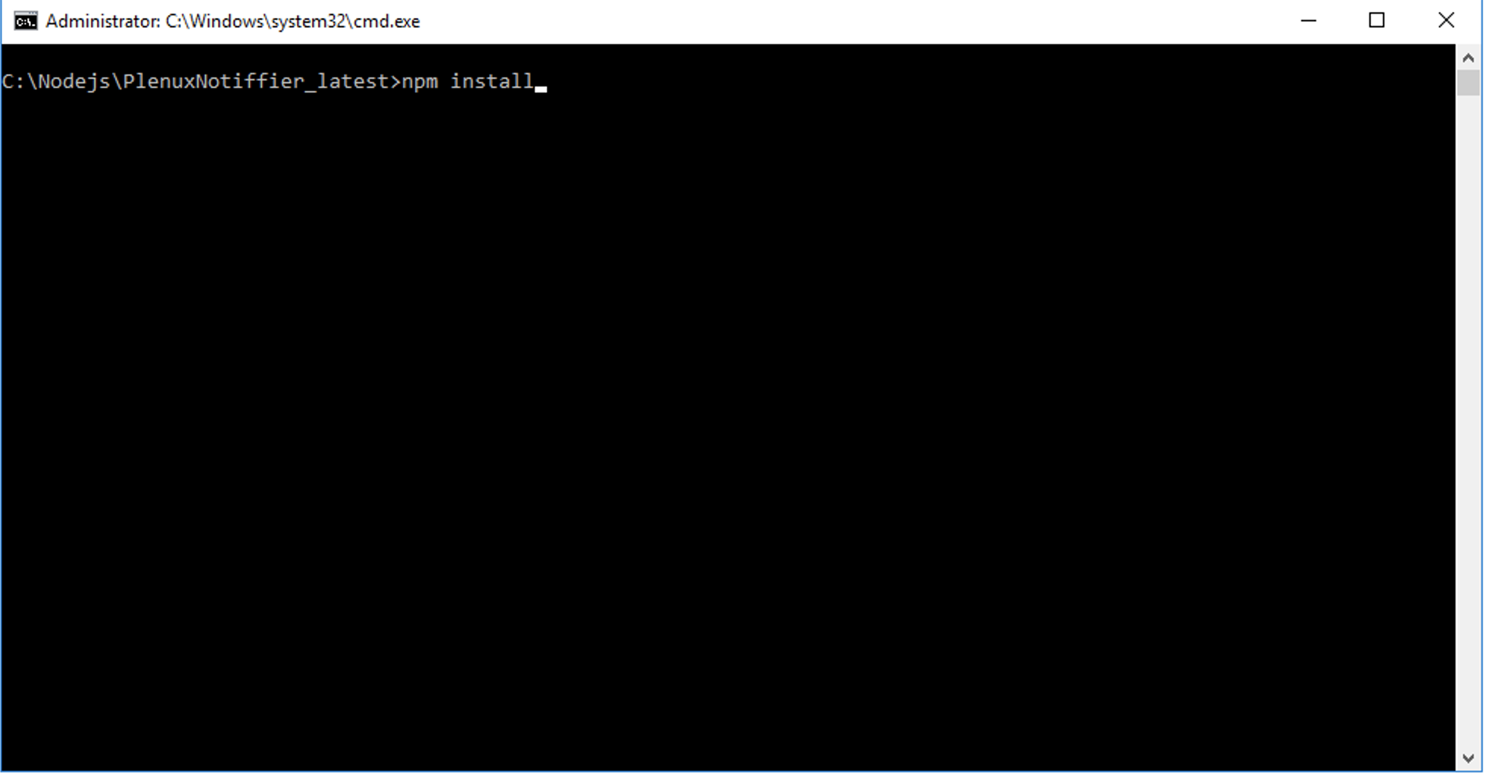

Now open settings.js file and change port and other paths .



If ssl is enabled then ssl: true and add ssl certificate and key to notifier root folder

Eg : www_plenux_com.key and www_plenux_com.crt

**Run as services**

open cmd with administrator and navigate to nssm folder

nssm install serviceNameExamp3 C:\Windows\System32\cmd.exe /c node path to index.js

eg: path to app.js => c:\Nodejs\plenuxNotifier_latest\index.js